CL 2006 OPERATING SYSTEM

BS Software Engineering




Lab 15: Conditional Variable and Counting Semaphore:

Conditional Variables:
Condition variables are synchronization primitives used to allow threads to wait for certain conditions to become true. They are typically used in conjunction with a mutex to manage access to shared data.
Condition variables are used when threads need to wait until a specific condition is met before proceeding (e.g., a buffer is not empty, or a resource is available).

Associated Functions:
• wait(): Releases the associated mutex and blocks the thread until it is signaled.
• signal(): Wakes up one thread waiting on the condition variable.
• broadcast(): Wakes up all threads waiting on the condition variable.

Mutex Usage:
The mutex is used to protect shared data, ensuring that only one thread modifies it at a time. Condition variables work with the mutex to avoid race conditions.

Example 1:
A thread waits until another thread signals a condition.
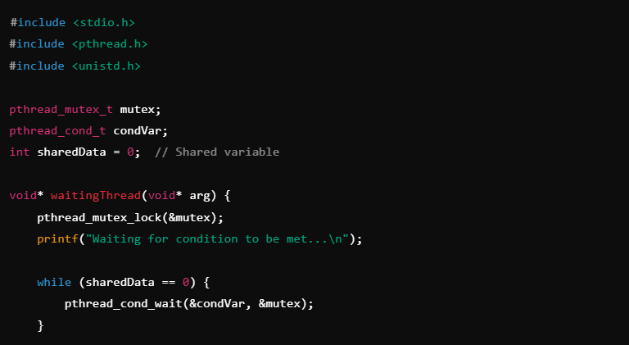
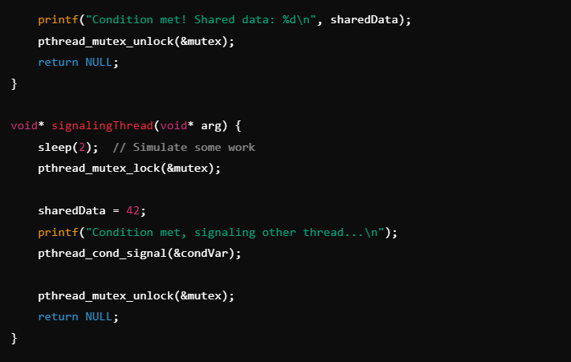
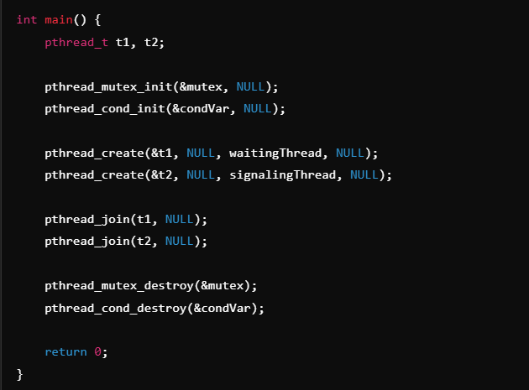

Output:
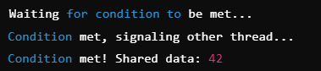

Example 2:
A producer thread produces items, and a consumer thread consumes them when available.
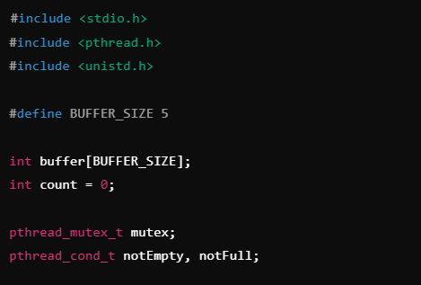
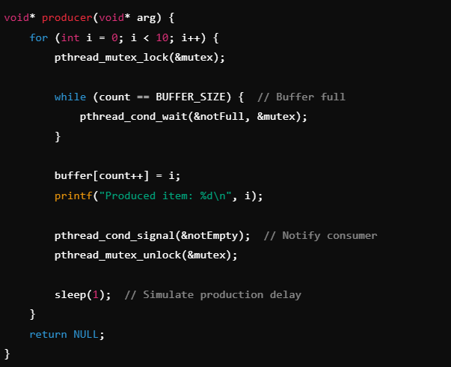
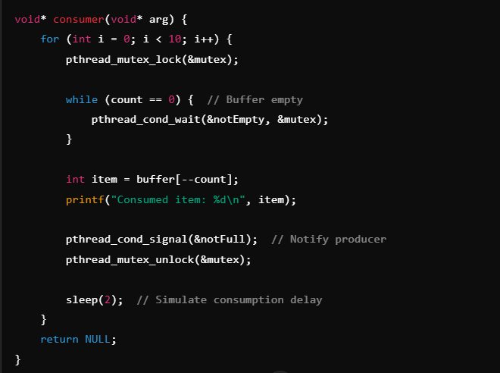
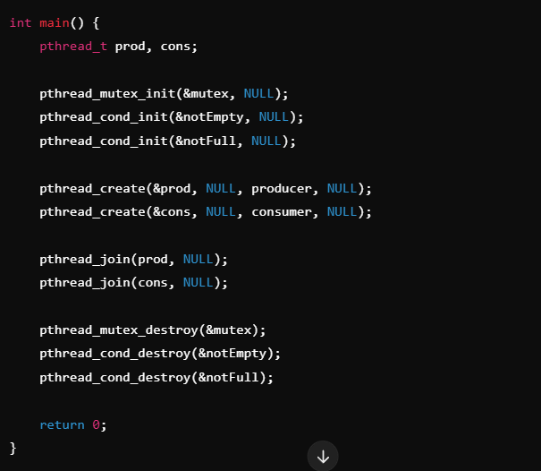

Output:
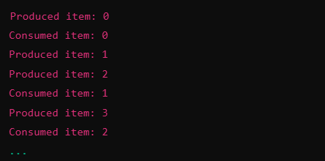
A condition variable always works with a mutex.
The mutex ensures that changes to shared data are safe while threads are waiting or signaling.

Why Use while Instead of if in wait()?
Spurious wakeups can occur, or the condition might not hold due to other threads. Using while ensures the condition is rechecked.
Condition variables can wake up a thread even if no other thread has signaled it. These are called spurious wakeups, and they occur due to reasons like hardware or OS-level optimizations. If the condition is not re-checked after waking up, the program could proceed incorrectly.

Counting Semaphore:
A counting semaphore is a synchronization primitive used in concurrent programming to control access to a shared resource. It maintains a counter that represents the number of permits available. Unlike binary semaphores (which are limited to values 0 or 1), counting semaphores can have any non-negative integer value.

Key Concepts:

Counter Value:
The counter starts with an initial value, representing the number of available resources.
Every time a thread acquires a resource (decrements the counter), the counter is reduced by 1.
When a thread releases a resource (increments the counter), the counter increases by 1.

Operations:
wait() (also known as P(), down(), or acquire()): Decrements the counter. If the counter is 0, the thread blocks until the counter becomes greater than 0.
post() (also known as V(), up(), or release()): Increments the counter, potentially unblocking a waiting thread.

Blocking:
If the semaphore counter is zero and a thread tries to perform a wait(), it is put into a waiting queue until another thread calls post().

System Calls:

sem_init:
Initializes a semaphore.
- sem: Pointer to the semaphore to initialize.
- pshared:
  - 0: Semaphore is shared between threads of the same process.
  - 1: Semaphore is shared between processes (requires shared memory).
- value: Initial value of the semaphore.
Return: 0 on success, -1 on error.

sem_wait:
Decrease the semaphore value by 1 (wait).
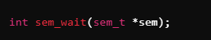
- Blocks the calling thread if the semaphore value is 0.
- Decrements the semaphore value when it is greater than 0.
Return: 0 on success, -1 on error.

sem_post:
Increase the semaphore value by 1 (signal).
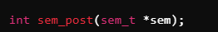
- Increments the semaphore value.
- Wakes up a waiting thread if there are any.
Return: 0 on success, -1 on error.

sem_destroy:
Destroy a semaphore.
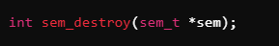
- Cleans up resources associated with the semaphore.
- Should only be called when the semaphore is no longer needed.
Return: 0 on success, -1 on error.

Examples:

Semaphore as a Lock:

Use Case:
Protect a critical section so that only one thread can access it at a time.
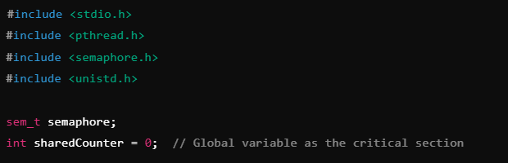
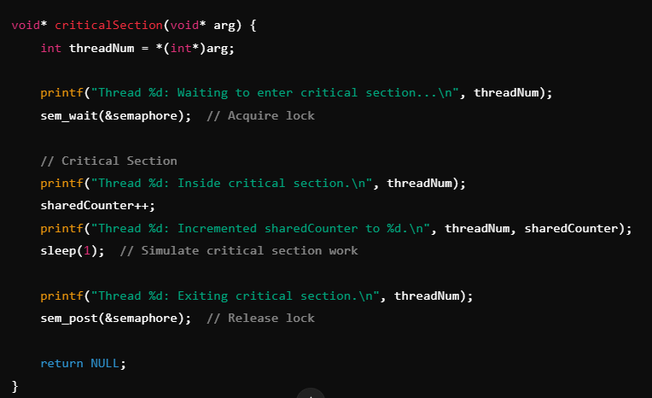
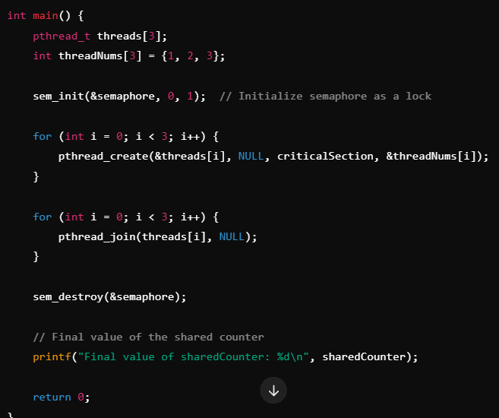

Output:
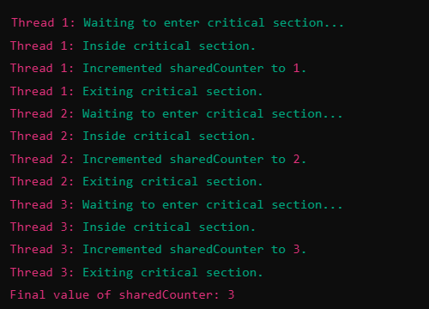

Semaphore for Counting Resources:

Use Case:
Limit access to a pool of resources (e.g., database connections).
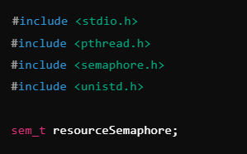
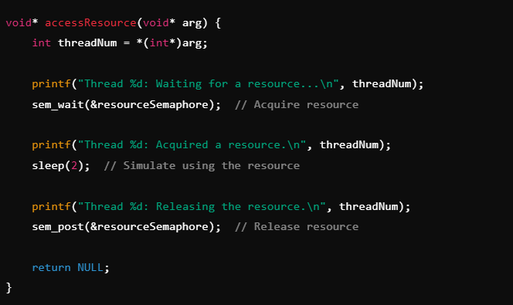
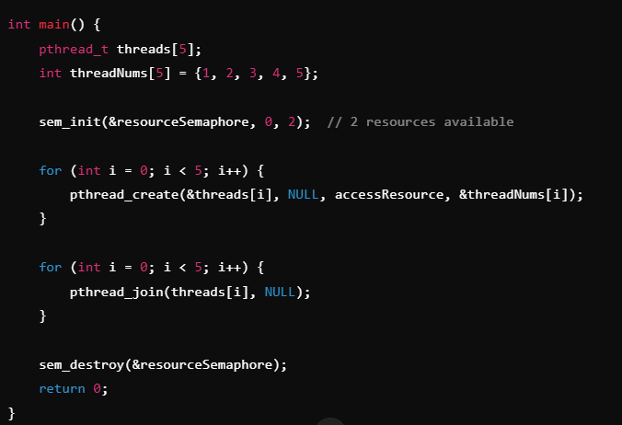

Output:
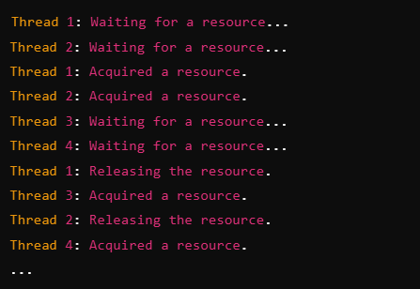

Semaphore as a Conditional Variable:

Use Case:
Signal a thread to proceed once a condition is met.
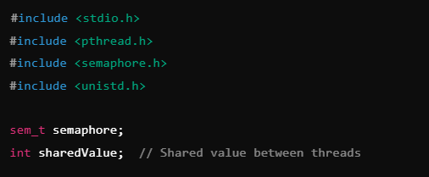
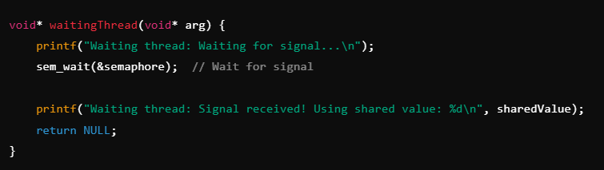
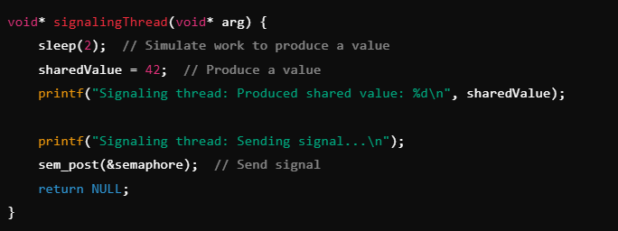
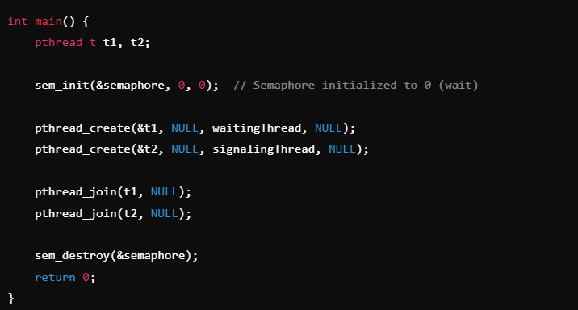

Output:
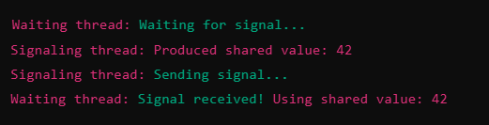

Tasks:
- Solve same producer consumer problem using semaphore only that is solved in this manual using conditional variables.

- You are tasked with managing a parking lot with 5 parking spots. There are 8 cars trying to park in the parking lot. Each car:
Waits for a parking spot to become available.
Parks the car (simulate parking by sleeping for 3 seconds).
Releases the parking spot when done.
Write a program to simulate this scenario using a counting semaphore. The parking lot has 5 spots available, and at most 5 cars can park at the same time.

- You are tasked with simulating a server that can handle a limited number of client requests. The server can handle 3 requests simultaneously. However, if there are more than 3 requests, additional clients must wait until the server becomes available.
There are 5 clients and a server that can handle 3 clients at a time. The server processes each request one by one. Each client requests a service and waits for the server to be available. Once the server completes processing a client's request, it signals the next client waiting in the queue.
Use a conditional variable to manage this synchronization, ensuring that no more than 3 clients are processed concurrently.
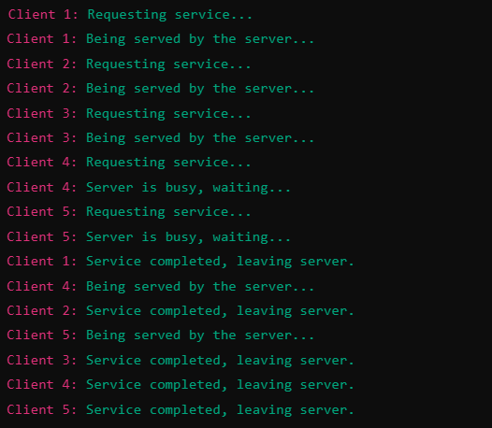

Task Submission Guidelines:
- Make a word document and paste the code with output’s screenshot there and save it as pdf.
- Include your name and roll no. at the front page.
- Files other than pdf will not be accepted and will be marked as 0.

